Atta Kulla Kulla 185

The Little Carpenter
February 25th, 2019

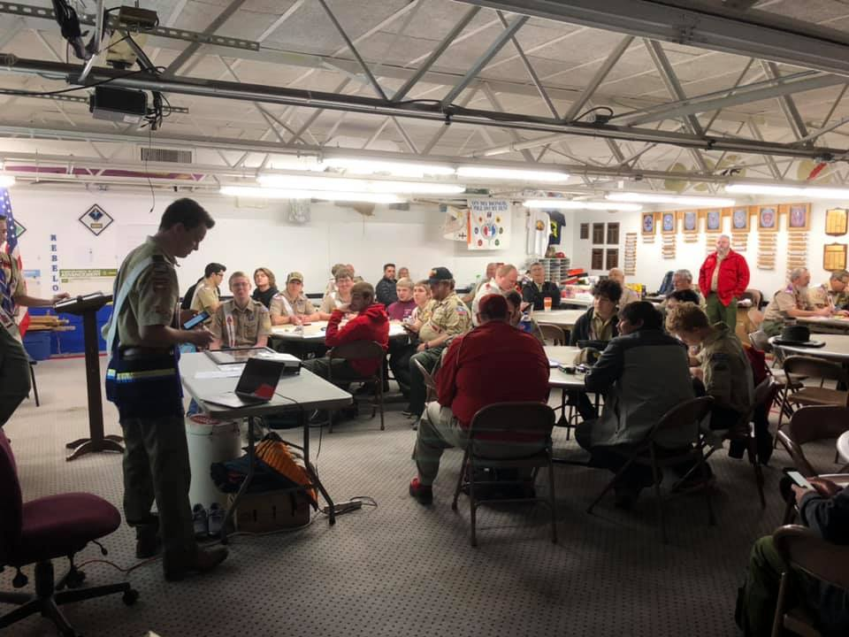

LLDC
On January 26th, the Lodge Leadership Development Conference was held for our lodge at Buncombe Street United Methodist Church. The Lodge had 7 different sessions Ranging from Chapter growth and development, to a vision of the future including youth girls joining the order over the summer. If you would like to view the schedule, it will be linked below. At the end of the day an ECM was held. At this ECM the Dixie theme of Greco/Roman was passed, Garrett Dean was sworn in as acting secretary, and Roberts rule of order was reestablished as the governing body of the ECM.

Winter Banquet
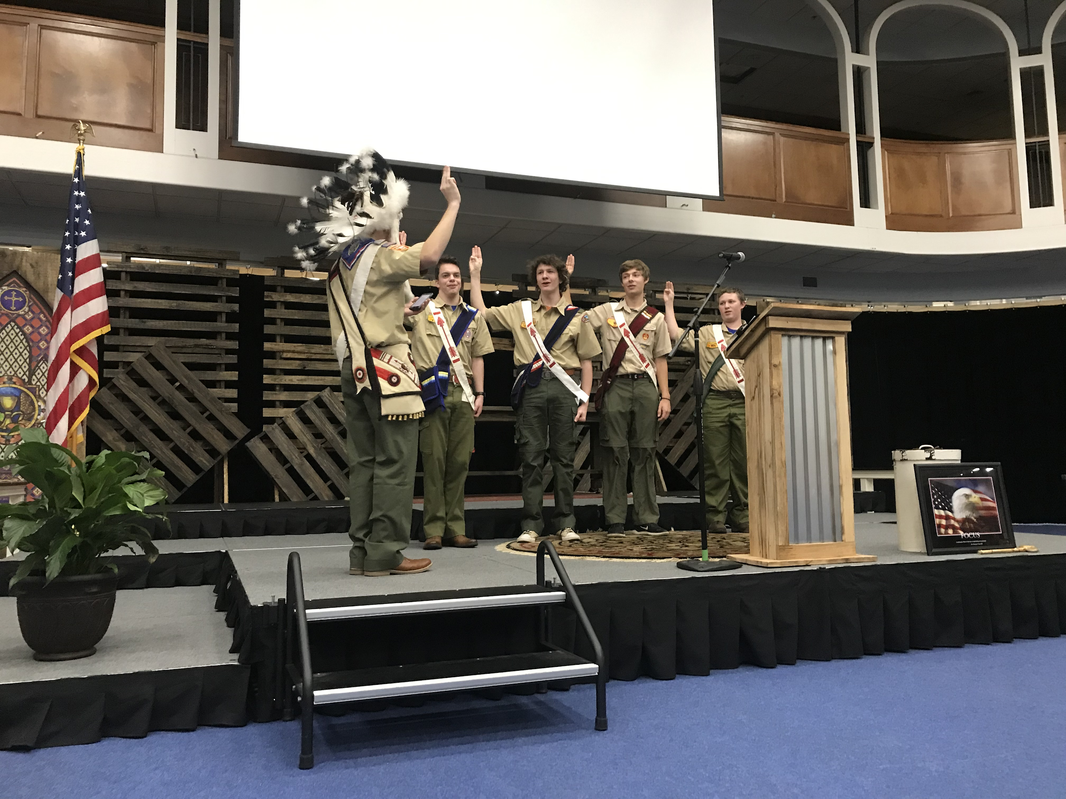
The 2019 winter banquet was an absolute blast. The meal of the night was low country boil, prepared by the wonderful chat and chew. The guest speaker was Marc Dopher, a previous sportscaster for channel 4 news. At the winter banquet, the 2018 lodge officers and advisors were recognized for their hard work and successful year. At the banquet, the annual awards of the Ted Dreibrodt, Ben Howard, and Founders Award were given out to individuals who went above and beyond the service to the lodge. The Ted Dreibrodt Living Legacy Award is given to one adult who has given a “lifetime” in cheerful service and decision to mentoring youth. This year, the Ted Dreibrodt Living Legacy Award was given to David Hollar. The Ben Howard Spirit of Service Award is given to a youth member of the lodge who shows exemplary service in all aspects of life, while also maintaining a positive and role-model like attitude. This year’s recipient of the Ben Howard Spirit of Service Award is Aidan Koschnitzki. Finally, the Founder’s award is bestowed upon an individual who demonstrate and memorialize in their everyday life the spirit of achievement as described by our Founders, Dr. E. Urner Goodman and Carroll A. Edson. The Founders Award criteria are also set forth by each lodge, meaning each has a special place in the hearts of the person who beholds them. The National Order of the Arrow has deemed the recipient to have already obtained their Brotherhood or Vigil honor and is presented to one youth and one adult. This year, the recipients of the Founders Award are Lawrence Coleman and Sandi Rice.

Spring Fellowship:
Mark your Calendars because March 15-17 is Spring Fellowship at Camp Old Indian! This is a great opportunity to serve with your brothers in the OA, and have times of brotherhood and bonding. At the fellowship, we will be doing service projects, playing chapter led quest events, and having outstanding food. Don’t forget that each chapter should have its own theme, which you guys get to create. However, your theme cannot be anything, it must still be scouting appropriate. When you have your theme and quest event planned, send them to Aidan at vca@akk185.org so we are able to approve it. This is also a time to move up spots on the chapter of the year board so you won’t want to miss it!

Lodge Officer Reports:
Lodge Chief: Benji Maguire
Hi all, I’m very excited to announce that spring fellowship is right around the corner. We are very prepared and want to invite you to spend the weekend fellowshipping and serving with us. If you have not gone through brotherhood, now would be an excellent time to do so! We are also planning on having a spirit board for all the chapter competitions and chapter of the year, so be prepared with your service hours. Finally, if you have any need, feel free to use my email listed below: chief@akk185.org.
Vice Chief of Administration: Aidan Koschnitzki
Hey everyone! I’m so excited for this year, especially all of the events that we have planned for the year. So far, we’ve had a successful LLDC and we are excited to be right around the corner from the Spring Fellowship! We’ve planned some great activities, made some changes and we can’t wait to see how everyone likes it, can’t wait to see y’all there! If you have any questions, feel free to email me at vca@akk185.org.
Vice Chief of Communication: Edward Ratliff
Hey guys. With the Spring Fellowship not far away we are gearing up to have a weekend full of service and fellowship! The lodge plan book is almost finished and will be available very soon. Coming with that, if you see any updates that need to be made to the website, please do not hesitate to email me at vcc@akk185.org as we are trying to get everything in order for Dixie fellowship.
Vice Chief of American Indian Activities: Garrett Kokay
Hey y’all. I’m excited to announce that our dance and ceremony teams are hard at work getting prepared for Dixie. The dance team has decided to do the spring frog dance and the bartheway dance. The ceremony teams are working diligently to memorize their lines and be ready for spring fellowship and Dixie. At our last AIA meeting, a two-year plan was instituted where the drum team will not compete at this Dixie, but will prepare for the one held in 2020 at Camp Old Indian. If you need anything involving the AIA, please contact me at vcaia@akk185.org.
Vice Chief of Inductions: Austin Silvers
Hi y’all. In preparation for spring fellowship I have reached out the Jeremy Baker, the camp ranger, and have settled on some service projects around camp. We will be working in the morning and part of the afternoon, and will have a very fun time doing so! We are really looking to promote brotherhood conversion this year, so keep up the hard work studying, and as always you can go through during the summer or at a fellowship. Please feel free to message me at vci@akk185.org.
Secretary: Garret Dean
Hello guys. We are very excited to see you at this upcoming spring fellowship and we know you will have a blast. I am currently in the process for keeping up with the minutes from all the previous ECMs, and helping wherever needed with the other lodge officers. Looking further down the road I cannot contain my excitement for Dixie, as it will be a blast and we are going to for sure win some competitions. If you need anything, here is my email and feel free to contact me: secretary@akk185.org.
Vice Chief of Dixie: Josh Kirchner
Hi guys, for those of you that do not know I am Josh Kirchner and have been elected to serve this two-year position as Vice Chief of Dixie. This means that I am in charge of helping coordinate this year’s Dixie, as well as planning the one next year hosted by Atta Kulla Kulla! I have reviewed the Dixie proposal numerous times, and am working with the other lodge officers to make sure everything is going to run smoothly. I am so excited and can’t wait till we can host Dixie in 2020!

