The Little Carpenter

Of Atta Kulla Kulla Lodge 185
The Official Lodge Publication of

Dixie Fellowship 2018 Recap
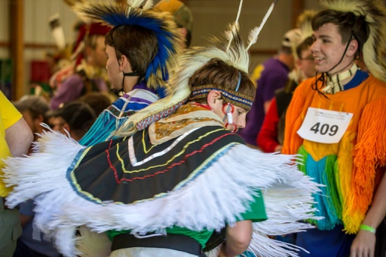
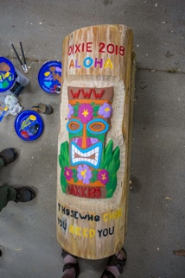
Greetings Brothers. My name is Garrett Kokay, I serve as Oolenoy’s chapter secretary. Dixie 2018, hosted by Skyuka Lodge, was an astounding experience. Our lodge participated in a number of AIA competitions, such as Ordeal and Brotherhood ceremony competitions, Drum competition, and Dance competitions. As well as many fun activities, including tug-o-war, ultimate frisbee, and egg toss! Furthermore, this past year we had the distinct privilege to have our very own Jakob Helderman serve as the 2017-2018 SR5 section chief. At Dixie we continued the tradition of electing a new chief, with this year’s being Cole Taylor from Skyuka lodge. Lastly, this year our lodge took home honor Lodge.
Officer Reports
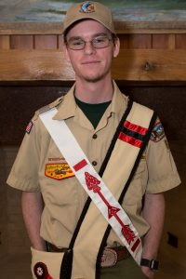Lodge Chief- JR Clark.
Greetings Brothers, My name is J.R. Clark. I am a sophomore at piedmont techniclal college studying computer science. I currently serve as the lodge chief of Atta Kulla Kulla. We have had a very sucessful year thus far and I can’t wait to see what is I store for us this susmmer. I hope to see you all at the lodege work day on the 9th of June. If you can’t make it to the workday hopefully I will see you all at the lodge cookout and vigil callout on the 27th of June. As always if there is anything I can do please reach out to me at chief@akk185.org.
VC of Administration- Thomas Rosznowski
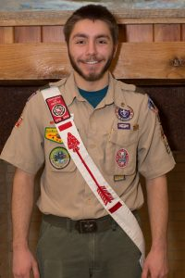Hello everyone, my name is Thomas Roznowski and I am your current VCA. I am from troop 84 and have been active in the OA for 3 years. Those 3 years have been packed with all kinds of activities/events, and I'm looking forward to even more.
Our last Major event was the Dixie Fellowship. As always, I had a blast, and so did everyone one else I talked to. Unfortunately, we did not get spirit award, but that just gives us the motivation we need to earn it at the next Dixie. I will be personally screaming at the top of my lungs every day until Dixie gets here to make sure that I am prepared. Together, with our collective screaming, we'll bring that spirit award back where it belongs.

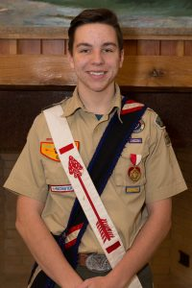VC of American Indian Activities- Benji Maguire
Hi, my name is Benji Maguire. We had teams competing in all AIA events; ceremonies, sing, individual and group dance. Everyone had fun and did their best, we came home with lots of ideas to work on for next year. In preparation for summer camp the AIA has put together teams for both Pre-Ordeal and Brotherhood, we are working on an Ordeal ceremony team. We have been working on the Wednesday campfire and finishing final details.

VC of Communications- Trent Kokay
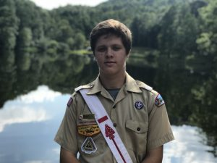Hey Guys, my name is Trent Kokay. I am a graduate of DW Daniel High School and a Brotherhood member of our lodge, we had a great turn out at Dixie this past month and have lots of great ideas for the future! Looking ahead at summer camp we have a great OA program laid out for all scouters to take part in from are Wednesday shows to our Friday ordeals! After summer camp we have NOAC 2018 where we have the opportunity to meet other Lodges from all over the nation. Hope to see you this summer at Camp Old Indian! -Trent Kokay

VC of Inductions- Lawrence Coleman
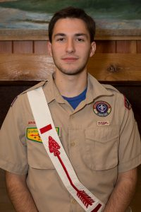My name is Lawrence Coleman. I am a sophomore at Clemson University studying physics. I am a brotherhood member as well as a ceremonialist for the lodge. I got my eagle in 2015, and I have always been passionate about nature. If you need to find me at camp, I am serving as the 2018 ecology director. The long summer cycle of Inductions has begun, and it brings with it the most important task if the order of the arrow. That task being to pass down our values of a brotherhood of cheerful service. Schedules, supplies, and registrations are being gathered in preparation, and I believe this will be a model year for our improved inductions process in every category but attendance.

Secretary- Kris Gilmer
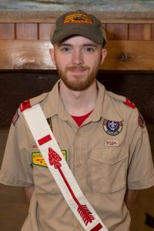Hello Brothers, My name is Kris, if you already do not know I am your 2017-2018 AKK Lodge Secretary. So far, this year has been a good one. Dixie went well. This year’s Dixie Fellowship was one of the most fun I have been to. The summer season is finally here which means that summer camp is as well. I hope a lot of you attend summer camp and join together with your fellow brothers in the fun that it will be. Summer camp is one of the best trips you can go on. You get to have fun, while doing merit badges, and you get too see even more brothers get inducted into the lodge. Don’t forget about the AKK Lodge Cookout. If you have not signed up you should, because the cookout is one of the best times to get together for fellowship. I hope everyone has a great rest of the 2018 year.
A Week of Adventure – COI 2018
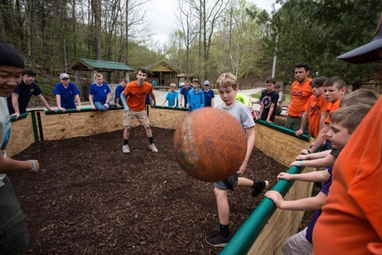
The 2018 Summer Camp Season is right around the corner, and the Camp Old Indian Staff cannot wait to host over 1,500 Scouts and Scouters from 16 different Councils spanning from all over the Country for 5 weeks of adventure, fun, and fellowship. From a brand new High Adventure program, to new Merit Badges be offered such as Aviation and Exploration, theres certainly something for everyone! When classes aren’t
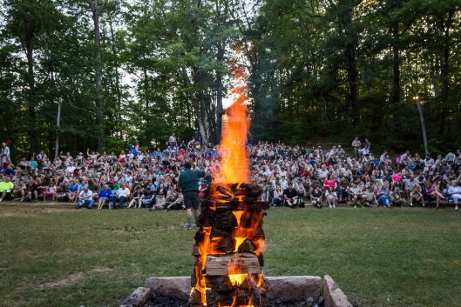
being taught, Campers can have fun playing in the brand new GaGa Ball pit, or by attending the new Movie Night Monday, which will be held following Twilight program each Monday night! We have big expecttions for our 92nd consecutive Summer Camp Season at COI, and we hope you will be apart of them! We look forward to seeing you soon! With WExcitement for whats ahead, Jakob Helderman | Camp Director of Logistics, Advancement, and Program Support
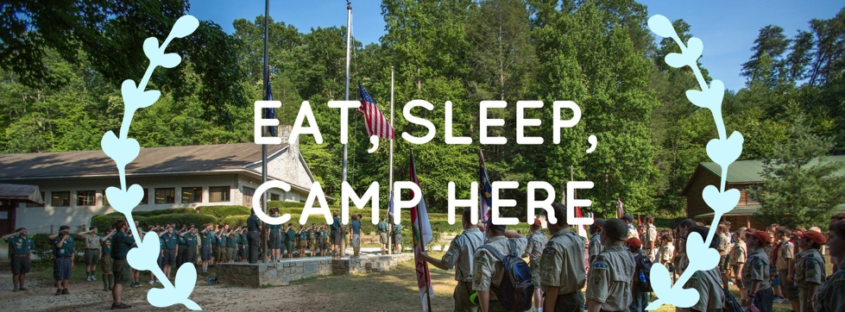

Lodge Workday
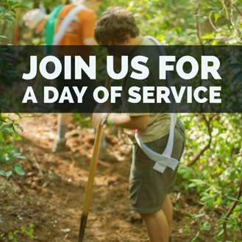
The Lodge workday at Camp Old Indian will be on June 9th from 9am -3pm. All participants in the lodge work day are required to bring a bag lunch, work gloves, sun protection, and water bottle. If possible, a few other items are needed such as: wheel barrows for mulch distribution, buckets and sponges to clean mattresses, spray disinfectant/cleaner, hose and nozzle, paper towels, and high quality duct tape to repair mattresses. Just to spice it up, there will be custom COI merchandise and a free collector patch available for all who participate at the Workday! Come check out the Program areas and sites! (Non-OA members are allowed to register for the Lodge workday.)
Lodge Cookout | Vigil Callout
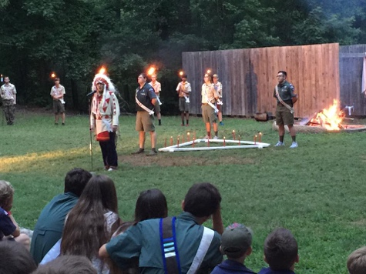
Our Lodge Cookout will be at Camp Old Indian on Wednesday, June 27th. The cookout will take place in the Activity Building, and check-in will begin at 5PM. All attendees should wear their full Class A uniform with sash. Just as a reminder to everyone, we will NOT be accepting walk-ups this year at the lodge cookout. This means you will have to register and pay before, or have an all access pass. Atta Kulla Kulla Lodge's annual Vigil Callout will immediately follow the Lodge Cookout in the amphitheater. This is a great opportunity to recognize and show your support for your fellow Brothers who have given back to our Lodge as they receive this great honor.

NOAC 2018
NOAC, also know as the National Order of the Arrow Conference, is approaching quickly! The Conference takes place at Indiana State University from July 30th through August 4th, bringing thousands of fellow Arrowmen from all around the Nation. For those of you who do not know, NOAC is an event which offers many opportunities from fellowship to service, and truly encompasses all of the values in the OA. From top notch training sessions to exciting evening shows, NOAC is not an event to miss! -Aidan Koschnitzki AKK Ceremonies Chairman

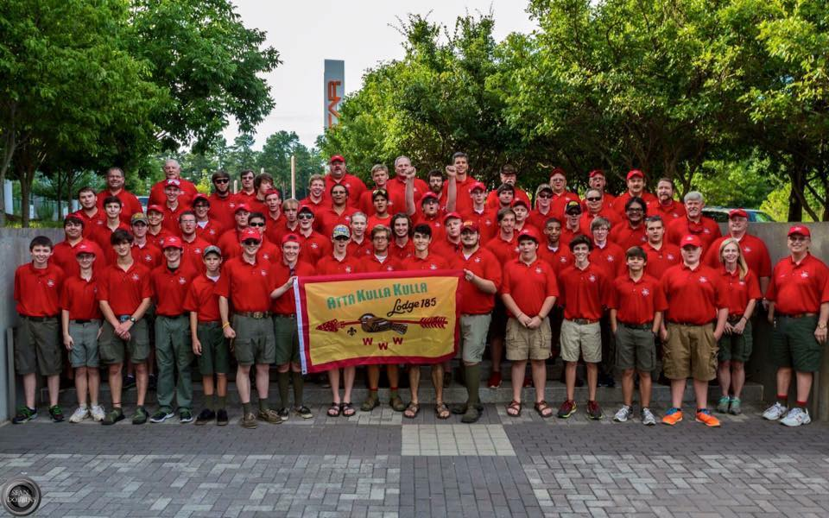
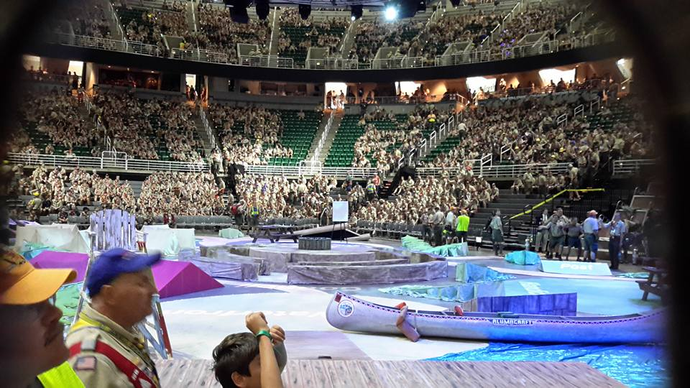

Membership Update
We belive that it is very important to keep the members of our lodge informed and uptodate on changes made by the National Committee this being said; As you may or may not know there has been a membership change for the Order of the Arrow, this decision was made by the National Committee. Below is the updated membership requiremnts take dircetly from the National fdWebsite
“Beginning February 1, 2019, unit elections will be permitted in Scouts BSA, Venturing and Sea Scout units. The new Order of the Arrow membership requirements are as follows:
- Be a registered member of the Boy Scouts of America.
- Have experienced 15 nights of camping while registered with a troop, crew, or ship within the two years immediately prior to the election. The 15 nights must include one, but no more than one, long-term camp consisting of at least five consecutive nights of overnight camping, approved and under the auspices and standards of the Boy Scouts of America. Only five nights of the long-term camp may be credited toward the 15-night camping requirement; the balance of the camping (10 nights) must be overnight, weekend, or other short-term camps of, at most, three nights each. Ship nights may be counted as camping for Sea Scouts.
- At the time of their election, youth must be under the age of 21, hold the Scouts BSA First Class rank, the Venturing Discovery Award, or the Sea Scout Ordinary rank or higher, and following approval by the Scoutmaster, Crew Advisor or Sea Scout Skipper, be elected by the youth members of their unit.
- Adults (age 21 or older) who meet the camping requirements may be selected following nomination to and approval by the lodge adult selection committee.
Our commitment to our unchanging mission and purpose remains steadfast, and we are excited to welcome others who share that commitment by extending membership in Scouting’s National Honor Society to participants of all older youth programs. We look forward to having female members in 2019 and know that, like all of our OA members, they will serve as role models and inspirations to others – both within the Boy Scouts of America and beyond.
We anticipate that you may have some questions. Please be sure to read the FAQ section below. We will have more information at the National Order of the Arrow Conference, which will be held July 30 – August 4, 2018, and we will continue to release additional information as it becomes available in order to assist our lodges with implementation. We look forward to sharing what the OA has to offer with more young people and appreciate your support of this exciting new direction.” – National Order of the Arrow Committee

